Government Engineering College, Thrissur
CS333– Application Software Development Lab
Documentation -
Exp 12 – Control Structures
Exp 13 – Procedures and Functions

Date of Submission
17 October 2020

Submitted By
Kowsik Nandagopan D
Roll No 31
TCR18CS031
GECT CSE S5

Experiment 12

AIM
Implementation of various control structures using PL/SQL

Description
Implement Control Structures in MySQL to get valuable insight from the previously created database. Functions available in MySQL are -
- CASE
- IF
- ITERATE
- LEAVE
- REPEAT
- WHILE
- LOOP

Output / Screenshots
1. IF - THEN - ELSE – THEN
Create a procedure using the control flow that gives the result whether the user is active or not

P. T. O
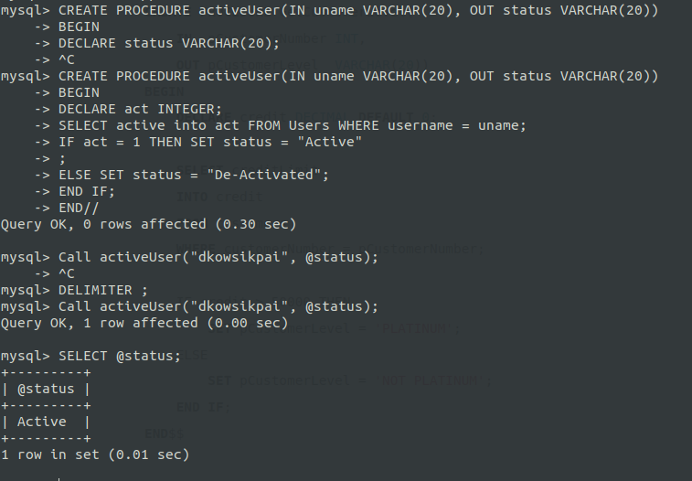
2. CASE
Get the project status from the procedural call
P. T. O
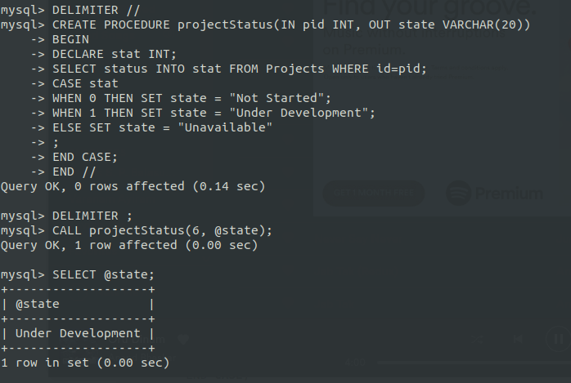
3. WHILE
Get the number of days left to finish date from the given date

P. T. O
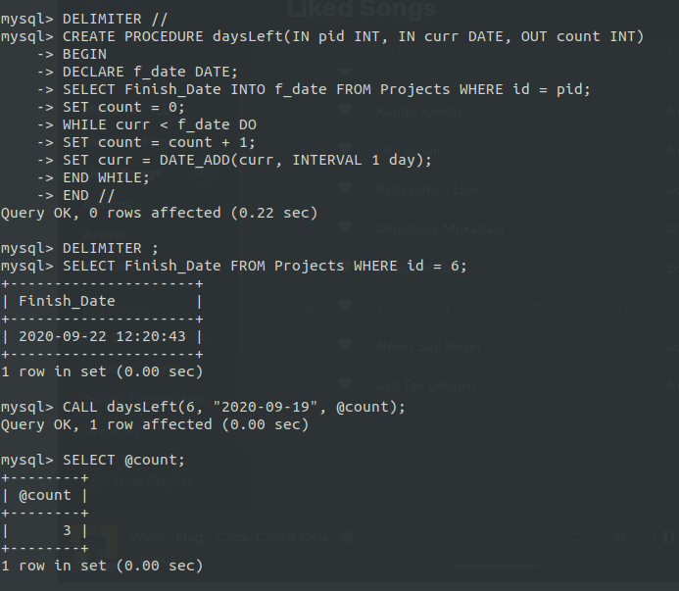
4. REPEAT
Use the Repeat to do the daysLeft
P. T. O
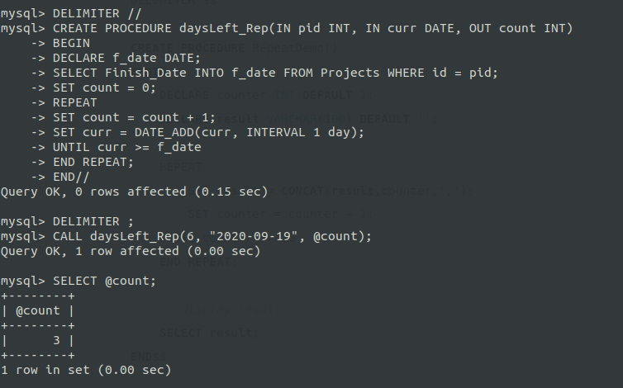
5. LOOP, ITERATE, LEAVE
DaysLeft using Loop, Iterate, Leave
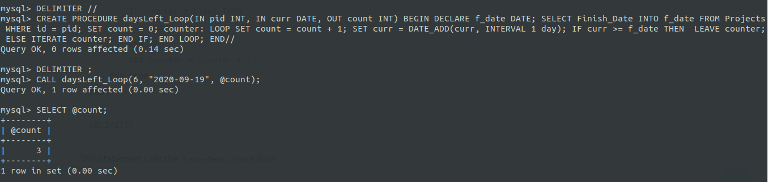

Experiment 13

AIM
Creation of Procedures and Functions

Description
Implement Creation of Procedures and Functions in MySQL to get valuable insight from the previously created database. Functions and procedures in MySQL are different.
Stored Procedure | User Defined Functions
Can return zero, single or multiple values | Must return single value
We can use transaction | We cannot use transaction
We can have Input / Output parameters | We can have only Input parameter
We can call function from procedure | We cannot call Procedure
We cannot use Procedure with SELECT/ WHERE/ HAVING statements | We can use it
We can use exception handing using Try-Catch | We cannot use Try Catch

Output / Screenshots
1. Function
Compute the daily cost for each resource by using the transaction table and resource table.
-- Table that will be used
SELECT PR.Project_ID, PR.Resource_ID, PR.Hourly_Rate, PR.ot_allowed, PR.ot_rate, PT.Effort_Spent, PT.Entry_Date FROM Project_Resources AS PR JOIN Project_Transaction AS PT ON PR.Project_ID = PT.ProjectID AND PR.Resource_ID = PT.Resource_ID;
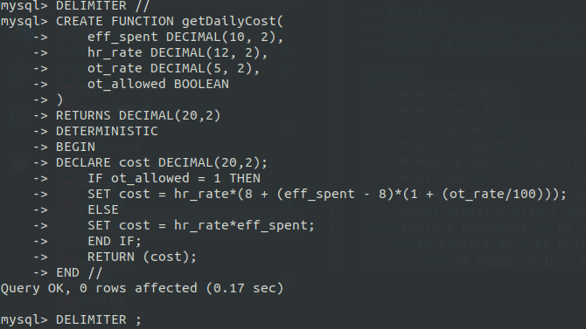
Calling Function
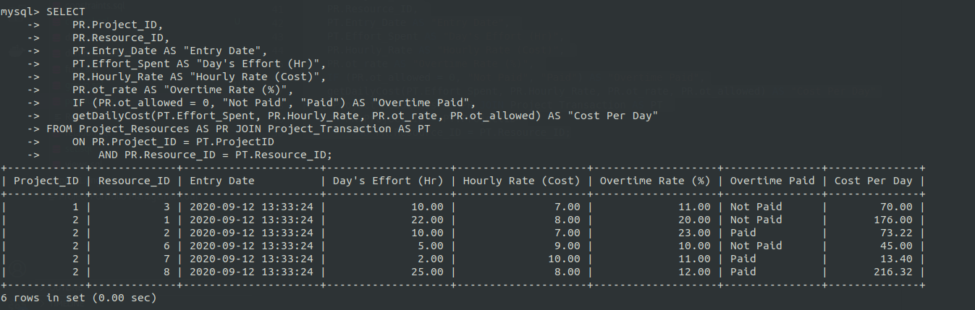

P. T. O

2. Procedure
Use above Function to get the above information and print the total cost for a particular resource for a particular project
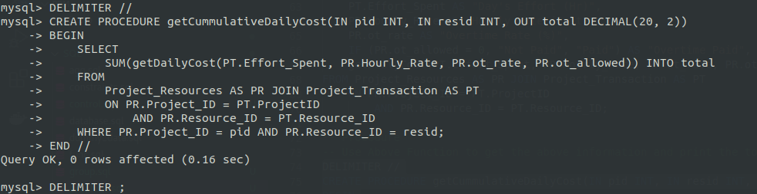
Calling Procedure
